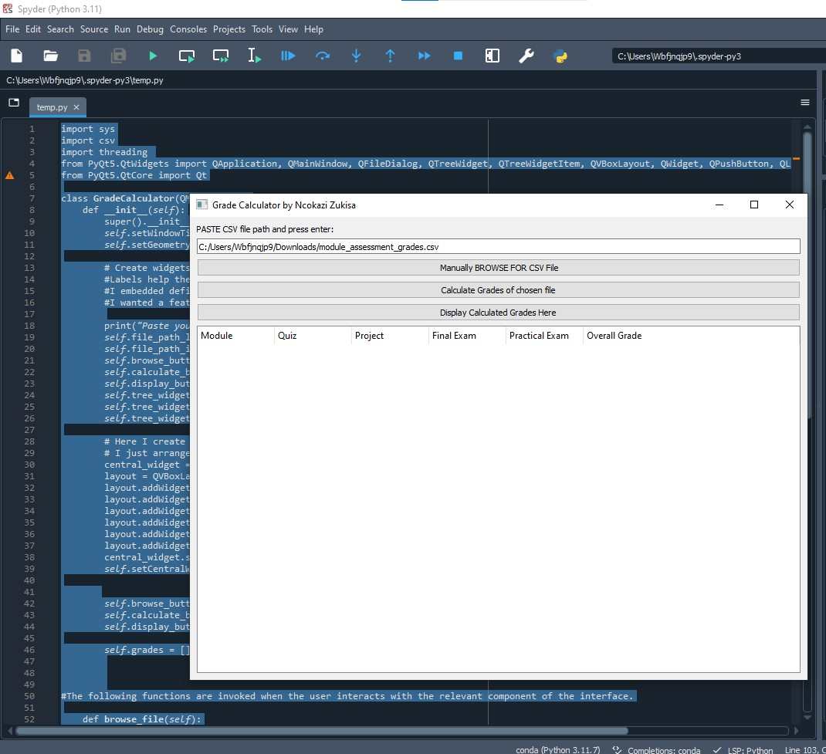

A user can paste the pathway of the CSV file here:



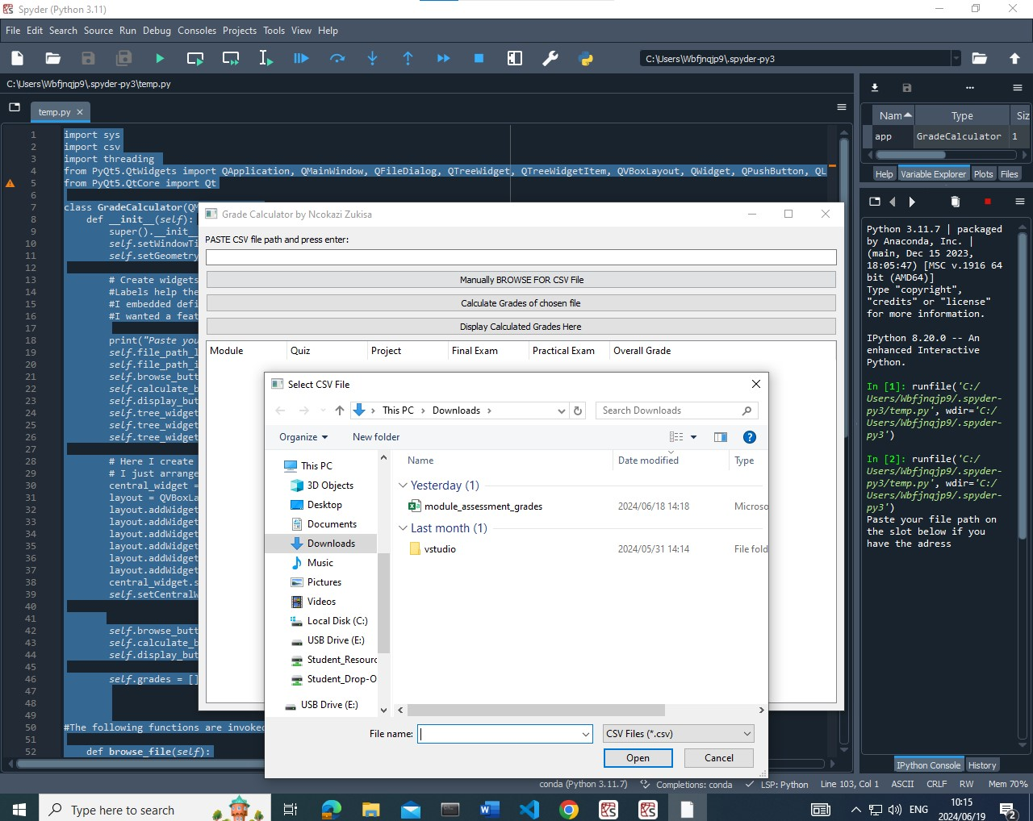

Alternatively, the user can just click the button with RED arrows next to it.



The RED button will take the user to their local library inside their computer for navigation.

After choosing the file, hit the calculation button indicated in betwixt the blue arrows



This is the calculated overall Mark.

Witness the power of the tool through the Tree widget.

